**SECTION 5:**

1. **Determining colour in the visible spectrum overview.**

import java.util.Scanner; public class ColorRange { public static void main(String[] args) {

// Create a Scanner object for user input

Scanner scanner = new Scanner(System.in); // Define the valid range for each color component int minRange = 0; int maxRange = 255;

// Prompt user to enter RGB values

System.out.print(&quot;Enter the Red component (0-255): &quot;);

int red = scanner.nextInt();

System.out.print(&quot;Enter the Green component (0-255): &quot;); int green = scanner.nextInt();

System.out.print(&quot;Enter the Blue component (0-255): &quot;); int blue = scanner.nextInt();

// Check if the RGB values are within the specified range boolean isValidRed = red &gt;= minRange &amp;&amp; red &lt;= maxRange; boolean isValidGreen = green &gt;= minRange &amp;&amp; green &lt;= maxRange; boolean isValidBlue = blue &gt;= minRange &amp;&amp; blue &lt;= maxRange;

// Display results

System.out.println(&quot;\nColor Component Validity:&quot;);

System.out.println(&quot;Red: &quot; + (isValidRed ? &quot;Valid&quot; : &quot;Invalid&quot;));

System.out.println(&quot;Green: &quot; + (isValidGreen ? &quot;Valid&quot; : &quot;Invalid&quot;));

System.out.println(&quot;Blue: &quot; + (isValidBlue ? &quot;Valid&quot; : &quot;Invalid&quot;));

// Close the scanner scanner.close();

}

}

CODE:

import java.util.Scanner;

public class ColorRange { public static void main(String[] args) {

// Create a Scanner object for user input

Scanner scanner = new Scanner(System.in);

// Define the valid range for each color component int minRange = 0; int maxRange = 255;

// Prompt user to enter RGB values

System.out.print("Enter the Red component (0-255): "); int red = scanner.nextInt();

System.out.print("Enter the Green component (0-255): "); int green = scanner.nextInt();

System.out.print("Enter the Blue component (0-255): "); int blue = scanner.nextInt();

// Check if the RGB values are within the specified range boolean isValidRed = red >= minRange && red <= maxRange; boolean isValidGreen = green >= minRange && green <= maxRange; boolean isValidBlue = blue >= minRange && blue <= maxRange;

// Display results

System.out.println("\nColor Component Validity:"); System.out.println("Red: " + (isValidRed ? "Valid" : "Invalid"));

System.out.println("Green: " + (isValidGreen ? "Valid" : "Invalid"));

System.out.println("Blue: " + (isValidBlue ? "Valid" : "Invalid"));

// Close the scanner scanner.close();

}

}

OUTPUT:

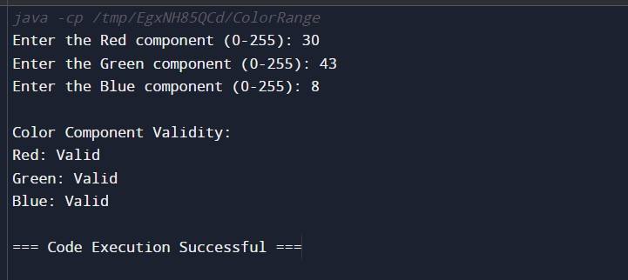

1. **Determining the next colour for a stop light**

import java.util.Scanner; public class TrafficLightChecker {

// Enum to define traffic light states

private enum TrafficLight {

RED, YELLOW, GREEN

}

// Method to get the next traffic light based on current light private static TrafficLight getNextLight(TrafficLight current) { switch (current) { case RED:

return TrafficLight.GREEN; case YELLOW: return TrafficLight.RED;

case GREEN:

return TrafficLight.YELLOW; default:

throw new IllegalArgumentException(&quot;Unexpected value: &quot; + current);

}

}

// Method to display the traffic light status private static void displayStatus(TrafficLight light) { switch (light) {

case RED:

System.out.println(&quot;The light is RED. Please stop.&quot;); break; case YELLOW:

System.out.println(&quot;The light is YELLOW. Prepare to stop.&quot;); break;

case GREEN:

System.out.println(&quot;The light is GREEN. You may go.&quot;);

break;

}

}

public static void main(String[] args) {

Scanner scanner = new Scanner(System.in);

// Prompt user for the initial traffic light state

System.out.print(&quot;Enter the current traffic light color (RED,

YELLOW, GREEN): &quot;);

String input = scanner.next().toUpperCase(); TrafficLight currentLight;

try {

// Convert the input string to TrafficLight enum currentLight = TrafficLight.valueOf(input);

} catch (IllegalArgumentException e) {

System.out.println(&quot;Invalid color entered. Please enter RED, YELLOW, or GREEN.&quot;); scanner.close(); return;

}

// Display the current light status displayStatus(currentLight);

// Determine the next traffic light state

TrafficLight nextLight = getNextLight(currentLight);

// Display the next light status

System.out.println(&quot;The next light will be: &quot; + nextLight); displayStatus(nextLight);

// Close the scanner scanner.close();

}

}

CODE:

import java.util.Scanner;

public class TrafficLightChecker { private enum TrafficLight {

RED, YELLOW, GREEN

}

private static TrafficLight getNextLight(TrafficLight current) { switch (current) { case RED:

return TrafficLight.GREEN; case YELLOW:

return TrafficLight.RED; case GREEN:

return TrafficLight.YELLOW;

default:

throw new IllegalArgumentException("Unexpected value: " + current);

}

}

private static void displayStatus(TrafficLight light) { switch (light) { case RED:

System.out.println("The light is RED. Please stop.");

break;

case YELLOW:

System.out.println("The light is YELLOW. Prepare to stop.");

break;

case GREEN:

System.out.println("The light is GREEN. You may go.");

break;

}

}

public static void main(String[] args) {

Scanner scanner = new Scanner(System.in);

System.out.print("Enter the current traffic light color (RED, YELLOW, GREEN): ");

String input = scanner.next().toUpperCase();

TrafficLight currentLight;

try {

currentLight = TrafficLight.valueOf(input);

} catch (IllegalArgumentException e) {

System.out.println("Invalid color entered. Please enter RED, YELLOW, or GREEN.");

scanner.close(); return;

}

displayStatus(currentLight);

TrafficLight nextLight = getNextLight(currentLight);

System.out.println("The next light will be: " + nextLight);

displayStatus(nextLight);

scanner.close();

}

}

OUTPUT:

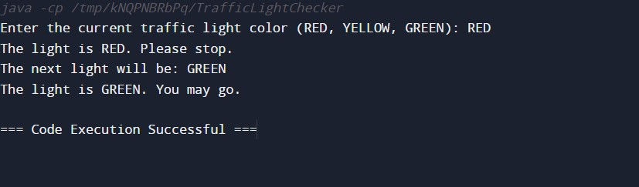

1. import java.util.Scanner; public class TrafficLightSwitch { // Enum to define traffic light states private enum TrafficLight {

RED, YELLOW, GREEN

}

// Method to get the next traffic light based on current light private static TrafficLight getNextLight(TrafficLight current) { switch (current) { case RED:

return TrafficLight.GREEN;

case YELLOW: return TrafficLight.RED; case GREEN:

return TrafficLight.YELLOW; default:

throw new IllegalArgumentException(&quot;Unexpected value: &quot; + current);

}

}

// Method to display the traffic light status private static void displayStatus(TrafficLight light) { switch (light) { case RED:

System.out.println(&quot;The light is RED. Please stop.&quot;); break;

case YELLOW:

System.out.println(&quot;The light is YELLOW. Prepare to stop.&quot;); break; case GREEN:

System.out.println(&quot;The light is GREEN. You may go.&quot;); break;

}

}

public static void main(String[] args) {

Scanner scanner = new Scanner(System.in);

// Prompt user for the initial traffic light state

System.out.print(&quot;Enter the current traffic light color (RED, YELLOW,

GREEN): &quot;);

String input = scanner.next().toUpperCase();

TrafficLight currentLight;

try {

// Convert the input string to TrafficLight enum currentLight = TrafficLight.valueOf(input);

} catch (IllegalArgumentException e) {

System.out.println(&quot;Invalid color entered. Please enter RED, YELLOW, or GREEN.&quot;);

scanner.close(); return;

}

// Display the current light status displayStatus(currentLight);

// Determine the next traffic light state

TrafficLight nextLight = getNextLight(currentLight);

// Display the next light status

System.out.println(&quot;The next light will be: &quot; + nextLight); displayStatus(nextLight);

// Close the scanner

scanner.close();

}

}

CORRECTED CODE:

import java.util.Scanner;

public class TrafficLightSwitch { private enum TrafficLight { RED, YELLOW, GREEN

}

private static TrafficLight getNextLight(TrafficLight current) { switch (current) { case RED:

return TrafficLight.GREEN; case YELLOW:

return TrafficLight.RED; case GREEN:

return TrafficLight.YELLOW; default:

throw new IllegalArgumentException("Unexpected value: " + current);

}

}

private static void displayStatus(TrafficLight light) {

switch (light) { case RED:

System.out.println("The light is RED. Please stop.");

break; case YELLOW:

System.out.println("The light is YELLOW. Prepare to stop.");

break;

case GREEN:

System.out.println("The light is GREEN. You may go.");

break;

}

}

public static void main(String[] args) {

Scanner scanner = new Scanner(System.in);

System.out.print("Enter the current traffic light color (RED, YELLOW, GREEN): ");

String input = scanner.next().toUpperCase();

TrafficLight currentLight;

try {

currentLight = TrafficLight.valueOf(input);

} catch (IllegalArgumentException e) {

System.out.println("Invalid color entered. Please enter RED, YELLOW, or GREEN.");

scanner.close(); return;

}

displayStatus(currentLight);

TrafficLight nextLight = getNextLight(currentLight);

System.out.println("The next light will be: " + nextLight); displayStatus(nextLight);

scanner.close();

}

}

OUTPUT:

